##### **Capstone – ShopNest PowerBI Nexusgoods Store**

**Question Statement:** Identify the rating distribution in the Shop_Nest dataset, showcasing ratings categorized as Excellent, Very Good, Good, Bad and Very Bad, along with corresponding orders.

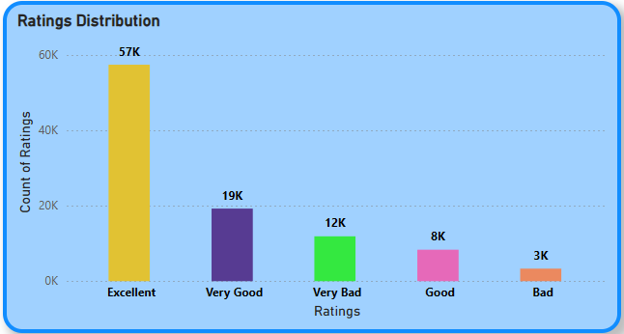**Visualization:**

**Explanation:**

* **Majority** of the feedback is positive, with 57% rated as “**Excellent”** and 19% rated as “**Very Good”.**
* 8% rated as “**Good**”, indicating the moderate level of satisfaction.
* 3% rated as “**Bad**” and 12% rated as “**Very Bad**”, which is a small portion of negative feedback.

**Question Statement:** What are the Top 10 and Bottom 18 most popular product categories in the ShopNest dataset? Please list them based on the number of orders.

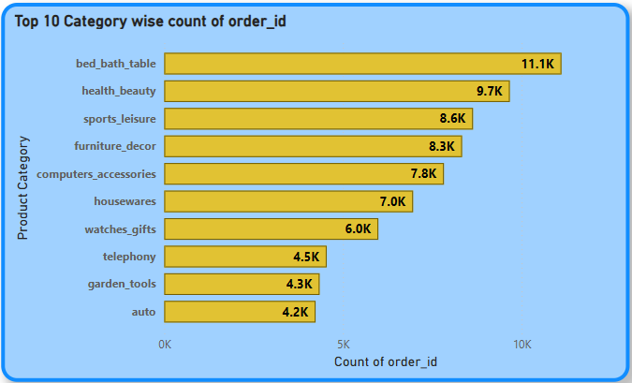**Visualization:** Top 10:

**Explanation:**

* **Bed_bath_table** is the most popular product categories with **11.1K** orders in total.
* Most of the products in product categories in the **Top 10** are the **essential products** which may require in the daily needs.

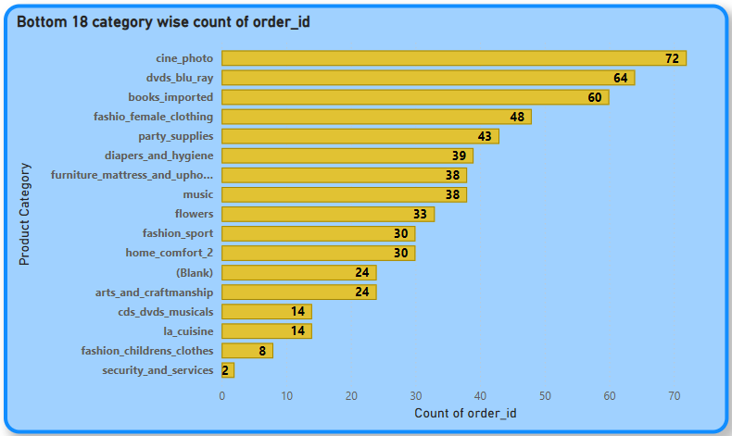**Visualization:** Bottom 18:

**Explanation:**

* These product categories in the **Bottom 18** are the **least required** products or avoidable product categories.
* **Security_and_services** have the least order count.

**Question Statement:** List the total number of active sellers by yearly and monthly.

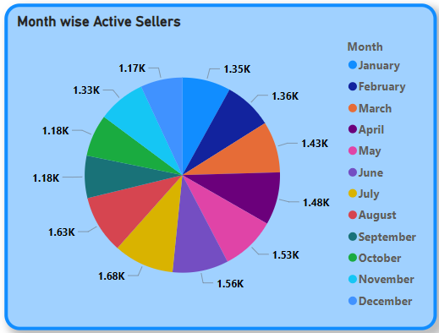**Visualization:** Monthly

**Explanation:**

* **July** month have the maximum number of **active sellers**.
* **December** month have the minimum number of **active sellers**.

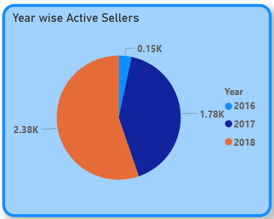**Visualization:** Yearly

**Explanation:**

* **Year 2018** have the maximum number of **Active Sellers.**
* **Year 2016** havethe least number of **Active Sellers**.

**Question Statement:** Which payment methods are most commonly used by ShopNest customers.

**Visualization:**

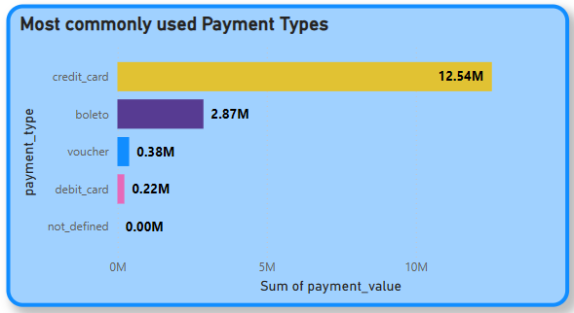

**Explanation:**

* **78.34%(12.54M)** of the total customers used **Credit card** as their 1st preference for payment type.
* **1.36%(0.22M)** of the total customers preferred **Debit card** as their payment type.
* **Credit card** is the most commonly used payment type, may be due to EMI facility/can be payable through installments.

**Question Statement:** Identify the product category- wise profit margin using the formula. **Hint: (Payment Value – Price + Freight Value) / Payment value * 100** (Rounded to two decimal points).

**Visualization:**

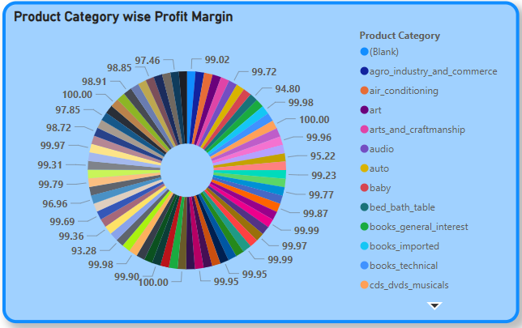

**Explanation:**

* Least profitable product categories are **watches_gifts** and **health_beauty.**
* Most profitable product categories are **security_and_services**, **home_comfort_2**, **fashion_childrens_clothes**, **cds_dvds_musicals** and **flowers**.

**Question Statement:** Determine the monthly payments made by the customers using credit cards.

**Visualization:**

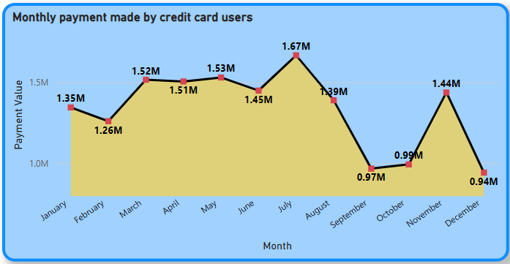

**Explanation:**

* **1.28M** customers used credit card as their payment type in the month of **July.**
* **0.74M** customers used credit card as their payment type in the month of **December.**
* **July** is the month where credit card payment value is the highest and **December** is the month where credit card payment value is the least.

**Question Statement:** Identify sellers categorized by city, excluding cities starting with the letters S and B.

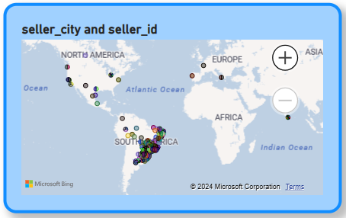**Visualization:**

**Explanation:**

* Most of the sellers belong to **South America.**
* Rest of the sellers belong from **North America, Europe** and **Sri Lanka.**

**Question Statement:** Create a dynamic visual that compares the number of delayed orders to the number of orders received earlier for each month. Utilize the drill through the cross-report feature to provide a detailed analysis of late and on-time deliveries.

**Visualization**:

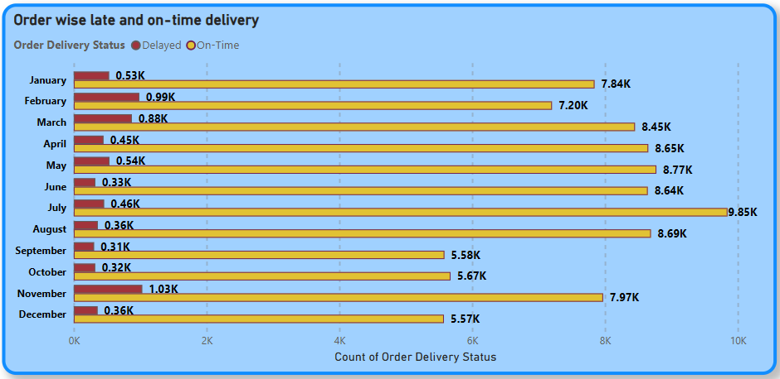

**Explanation:**

* **July** month have the highest On-Time Deliveries as compared to others.
* **November** month have the highest Delayed Deliveries.
* **Late deliveries** can be due to weather issues, traffic issues or vehicle breakdown.

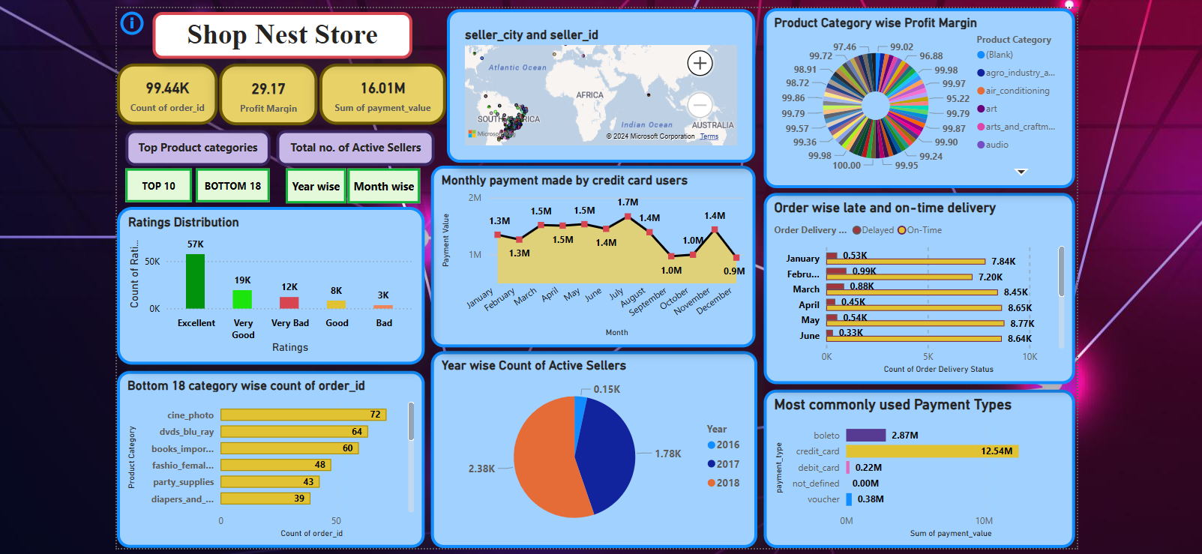**DASHBOARD**